Demo Report

Usage of different build.properties files:

We can use different build.properties files in apache-ant to access different accounts at the same time.

For example, if I need to access two Salesforce accounts to retrieve metadata I will create two build files and save it to the **bin** folder of apache-ant, let’s say:

1. build.properties.devqa - Contains the credentials of devqa sandbox
2. build.properties.prod – Contains the credentials of Acceptance sandbox

Now open command prompt navigate it to **bin** folder of apache-ant and run the command

‘ ant retrieveUnpackaged -propertyfile build.properties.devqa ‘.

This command will retrieve all the unpackaged components from devqa sandbox to the folder specified in the target of build.xml file.

Similarly, for acceptance sandbox run the command

‘ ant retrieveUnpackaged -propertyfile build.properties.prod ‘.

This will also do the same thing but from acceptance sandbox.

In this way we can use different build.properties files to access different accounts.

Devqa sandbox:

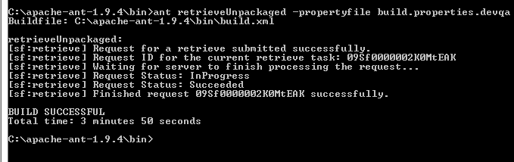

Acceptance sandbox:

